2023
LITTLE SOUTHWEST CONFERENCE 5TH/6TH FOOTBALL RULES/REGULATIONS

LEAGUE ORGANIZATION

The league is comprised of teams from the following cities:

COMMUNITY | YEAR OF  RESPONSIBILITY
OLMSTED FALLS | 2023
WESTLAKE | 2024
AVON LAKE | 2025
BAY VILLAGE | 2026
ROCKY RIVER | 2027
NORTH RIDGEVILLE | 2028
AVON | 2029
FAIRVIEW PARK | 2030
*NORTH OLMSTED (OFFICIAL SCHEDULE MAKER)
**LAKEWOOD (SCHEDULES OFFICIALS)

  - Each city is responsible to serve as League Director and provide oversight of the league as designated in the right hand column. The responsibility will rotate yearly.
  - The Director of Recreation, or designee, will represent each city and their respective teams.
  - Each Recreation Director, or designee, has one vote; simple majority decides all decisions regarding the rules/regulations of the league.
  - Rules may only be reviewed and changed by a vote of Recreation Directors, or designees.
  - No team may roster more than 40 players.
  - No team may consist of only 5th or 6th graders
  - League Director Responsibilities include but are not limited to:
    - Scheduling and oversight of pre-season organizational meeting to be held in July.
    - Preparation and distribution of all meeting minutes and league rules/regulations.
    - Receiving and distribution of team rosters.
    - Preparation and distribution of season schedules (will be handled by North Olmsted)
    - Scheduling Officials (The representative from the Lakewood City Schools shall schedule all officials.)

Player Eligibility
  - Player must be enrolled in 5th or 6th grade
    - Player may play a maximum of two years in the league
    - Player is ineligible to play if players 13th birthday falls before September 1st of current year
  - Weight Limit
    - No player may advance the ball or play in the offensive backfield who weighs more than 120 pounds (with clothing/equipment described below)
      - Each player will be weighed in before each game/scrimmage and must wear at least the following:
        - Undershirt
        - Game pants with pads including girdle, jock, and protective cup
        - Game shoes/cleats
      - This rule does not apply to the punter or field goal kicker
      - Players weighing over the limit must have a clearly visible and identifiable off team colored “Sticker” placed on the backside of their helmet during play.
      - Each team is responsible to have “Big Boy” stickers available and in place on players weighing over the limit.
      - The host team is responsible for providing a representative and an accurate scale for weighing in all teams

Coaches must provide game day rosters to the representative at the scale that lists players name and number
      - Players not present for pregame weigh-in can’t play until after being weighed in at half-time.
      - The host team in addition to a scale must provide a 10 pound weight to verify the scales accuracy if requested
      - Teams may have only one coach at the scales to confirm players weight
  - Rosters
    - Rosters, including grade level, must be submitted to the League Director prior to the first scrimmage
    - A player cannot change teams after the first league game; however, new players can be added to the roster
    - Rosters may not exceed 40 players
  - Injured Player
    - In the event of a player injury, which causes a time-out, the player must be removed for at least one play
    - A head injury disqualifies the player for the day and the player must have a signed doctor’s permit to resume subsequent practice and play
  - Flagrant Foul
    - Any player who deliberately commits a flagrant foul or unsportsmanlike conduct (including profanity) must be expelled for the remainder of the game. Any flagrant foul must be noted with the League Director

Player Participation
  - All players must play a minimum of 10 plays of offense or defense. The only exceptions are if the player is being disciplined or has been injured.
  - There is no limit on substitutions.
  - Players shall be at all games at least 30 minutes prior to the start of the game for roll call, equipment check and weigh in.

Sideline Control
  - Only active coaches and players are permitted on the sidelines. Non players and parents are not permitted. Coaches must enforce this rule.
  - Coaches and players not in game and spectators must remain off the playing field and out of the end zones. Coaches must enforce this rule. Officials are instructed to stop the game if necessary.
  - One coach from each team may be in the huddle during the first game.
  - Coaches are asked to have their team organized and ready to take the field at the two minute warning of the prior game.
  - Coaches are asked to have their team leave the field as quickly as possible following the conclusion of the game so the next game can begin.
  - Any coach that is ejected from a game will be suspended for two games, a second ejection will result in lifetime ban from participating in the league.

Player Equipment
  - All players must wear the required equipment at all times while on the playing field:
    - Helmet on, chinstrap buckled and mouthpiece in (helmet must have approved stamp)
    - Shoulder pads and jersey
    - Game pants with pads including girdle, jock, and protective cup
    - Game shoes/cleats - molded all-sport shoes permitted / NO METAL CLEATS
  - Forearm and hand pads made of soft material are acceptable; doctor’s approval is needed for all casts
  - No jewelry permitted, unless medical alert

Game Equipment
  - The Under Armour 495 Youth Composite football or equivalent will be used in the league.
  - No walkie-talkies or electronic equipment permitted
  - End zones will be marked with pylons, cones, or red flags
  - Kicking or block should be up to 2"

Practices
  - Practices may be no more than four times a week
  - Practices may be no more than three times per week after August 14th
  - Practices may be no more than two hours in length
  - Practices can begin no earlier than July 31
  - Players must have at least four days of conditioning prior to contact. Contact practices can begin no earlier than August 7th

- Last Week of Season Schedule
  - The last week of the season will look to match up similar skilled opponents. This is not a championship game, but an effort to have a competitive last game of the season for all teams.
  - The following system for the last game of the year will follow this set of criteria (in order):
    - No same community matchups
    - No matchups if played during the season
    - Wins and Losses
    - Points Against
    - Point Differential (only up to 20 will be counted)
    - Coin Flip

Games Rules - (NOTE: any ruling not specifically covered here shall be governed by the Ohio High School Federation Rules)
  - Start of game
    - Weather
      - All games are to be played regardless of weather; except thunder and/or lightning. National Federation Lightning Disturbances Guidelines must be followed
      - Recreation Director, or designee, may postpone games due to inclement weather and/or poor field conditions determined to be unsafe for players

    - Number for participation
      - Teams must be able to field 11 players at all times
    - A team will forfeit if it is unable to field 11 players within 15 minutes of the official starting time
    - Coin Flip
      - A coin flip will award the winners with the choice of either possession of the ball to begin the game, choice of direction of play, or to defer possession to the start of the second half.
    - Officials
      - Only persons registered by the Ohio High School Athletic Association shall be qualified.
      - No game can be started without the appointed officials on the playing field.

  - Length of playing field
    - The field will be 100 yards long from goal line to goal line when facilities permit with an 80 yard minimum length.
    - The ball will be put in play 40 yards from the offensive teams’ goal line for a 100 yard field and 35 yards from the goal on an 80 yard field.
    - The ball will be put into play this way after a touchdown has been scored
    - There will not be a kickoff

  - Conversion Attempts – P.A.T. and Field Goals (stop clock, following the kick the offensive team will have 30 seconds to put the ball in play once the game official sets the ball)
    - P.A.T. – the try for the point after kick will be snapped from the eight- yard line and placed on a block on the fifteen-yard line. No attempt can be made to block the kick. Hands must be down.
- Point Values
  - Run: 1 point (snapped from 3-yd line)
  - Forward Pass: 2 points (snapped from 3-yd line)
  - Kicking PAT: 2 points (snapped from 8-yd line)
- Field Goal

If coach declares his team kicking a field goal, the attempt must be made within the normal 30 second game clock. Once the decision has been informed to the referees and other team, the decision cannot be reversed. The ball must be kicked.

The ball will be snapped from the line of scrimmage on FG attempts and held and placed by a holder on a block
- No attempt may be made to block the kick
- Any missed field goal attempt longer than 20 yards, the ball shall be spotted at the original line of scrimmage
- Any missed field goal attempt shorter than 20 yards, the ball shall be placed at the 30 yard line

  - Touchback
    - If there is a touchback, the ball will be put into play 20 yards from the goal line
  - Safety
    - If a safety is scored, the scoring team will put the ball into play at midfield
  - Penalties
    - All penalties both major and minor will follow OHSAA rules.
    - A minor penalty will be assessed against the team of a player who, after one warning, is detected not wearing a mouthpiece
  - Quarters
    - Official time will be kept by the lead official on the field
    - Each game will consist of 4 – 15 minute running quarters
      - The clock will only stop on P.A.T., Field Goal Attempt, player injury, team timeout, or as deemed necessary by the game officials
    - The last two minutes of each half will be stop clock – regular National Federation High School clock.
    - The game officials will announce the two-minute warning
    - Each team is permitted 2 time outs per half
    - Halftime - 10 minute
    - Teams trailing by 21 points or more in the second half shall only need 5- yards on offense to gain a first down. This rule will be in effect until the team is within a 21 point deficit.
  - Offensive Team
    - Must play a balanced line (equal spacing tackle to tackle) on the line of scrimmage. Offensive tackles must be covered by an end or split end at the snap of the ball.

No crack-back blocks: downfield blocking will be limited to above the waist. Cross body blocks allowed within 3 yard of the line of scrimmage and from tight-end to tight-end
    - A tight end over the legal ball carrying weight (120 lbs.) is an ineligible receiver and may not advance from the line of scrimmage during a pass attempt. To be ruled as an ineligible player down field.
    - Putting the ball in play: An offensive team is allowed 30 seconds to put the ball in play after setting of the ball by the officials from the previous play.
    - 4th down options: The offensive team will elect one of the two options and must declare their intentions before the start of the play:
      - Put the ball in play as a regular offensive play
      - Punt
        - The ball will be placed 25 yards from the punting team’s line of scrimmage
  - Defensive Team
    - Formations: 4-3 defense must be used unless the offensive team is inside the 10 yard line. If the offensive team is inside the 10 yard line a seven man line may be used
    - Except for the defensive ends, all linemen shall assume a 3 or 4 point stance
    - A maximum of seven defensive players (four of which must be lineman) may be in the tackle box prior to the snap of the ball. The tackle box will be defined as five (5) yards from the LOS and five (5) yards from each OT (Fig 1). All defensive lineman must be in a head to head alignment with the offensive guards and tackles (no gap alignment) as shown below. (Fig 2). The other three players in the tackle box must be a minimum of three yards from the LOS in an upright stance. All other defensive players may lineup where they want but may not be in the tackle box as defined herein.
    - From the 10 Yard Line in, the defensive tackles may line up in the guard center gaps.
    - Blitzing or stunting is not permitted. Blitzing is defined as any forward movement by the linebacker or defensive back before the ball is snapped. Stunting is defined as a forward movement prior to the snap. All officials will be made aware of this rule prior to each contest. A 5-yard penalty will be assessed
(Fig 1)
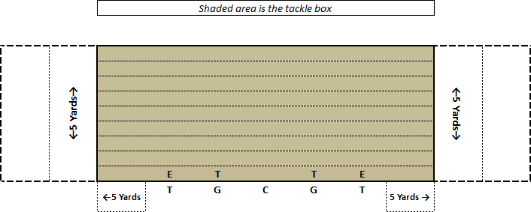

(Fig 2)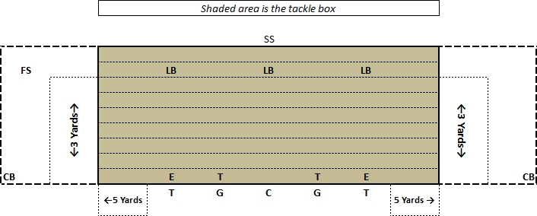

  - Tackling
    - Officials will blow a “quick whistle” to avoid piling on
  - Tie game at the end of regulation
    - There are no overtime periods for games tied at the end of regulation play.

